**Thermo-Pro®**

**“THERMALLY INSULATED PROFILES FOR EWI**

**PRODUCTGUIDE**

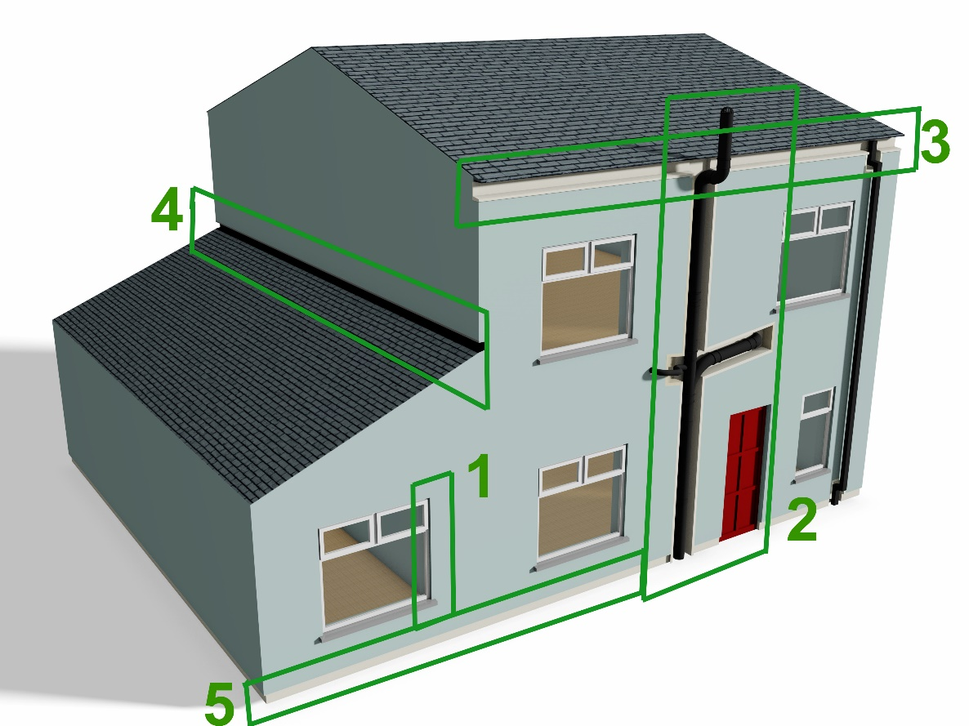

* **Faster Installations.**
* **Reduce risk of onsite damage.**
* **Superior Weatherproofed and Pre-finished solution.**
* **No thermal breaks in EWI.**
* **Reduced Disruption to access.**
* **The Thermo-Pro profiles can be fitted ahead of the main insulation works without scaffolding.**
* **Simplifies the job of the primary EWIS contractor.**
* **Increased Internal Surface Temperature**

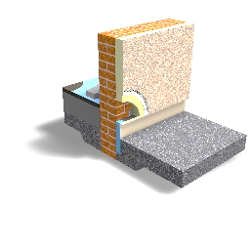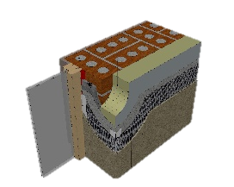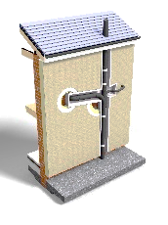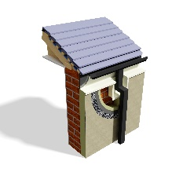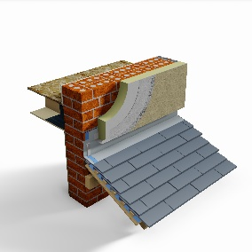

**2**

**3**

**4**

**1**

**5**

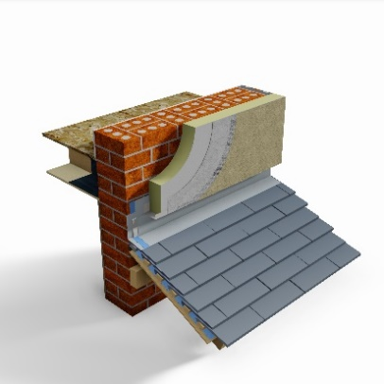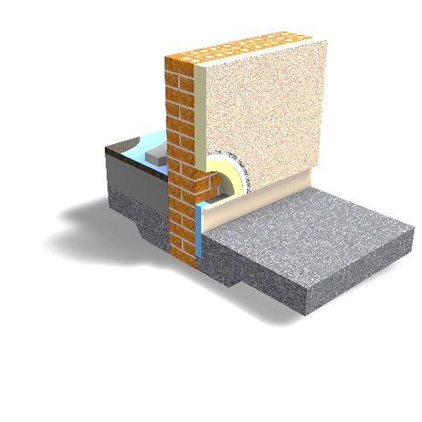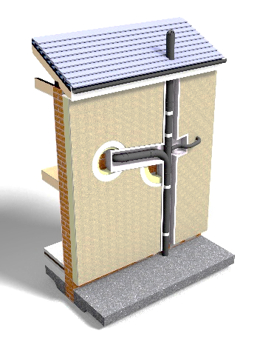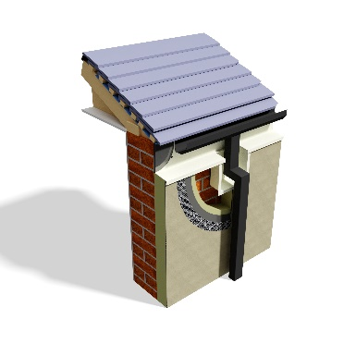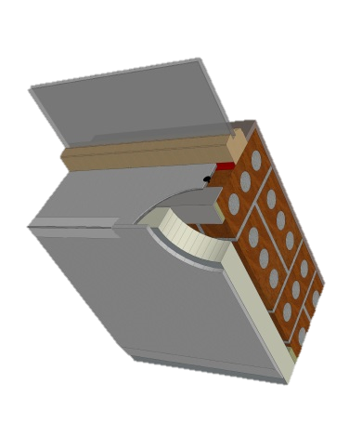

**INTRODUCTION.**

**Cold Bridging in EWI.**

**Product Range.**

**1- THERMO-BEAD.**

**2 - THERMO-PRO SOIL PIPE.**

**3 - THERMO-PRO RAINWATER- FASCIA.**

**4 - THERMO-FLASH.**

**5 - THERMO-TRAC.**

**PRODUCT DETAILS.**

**CONTENTS**

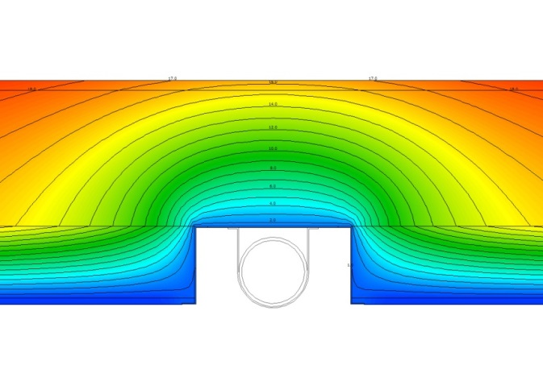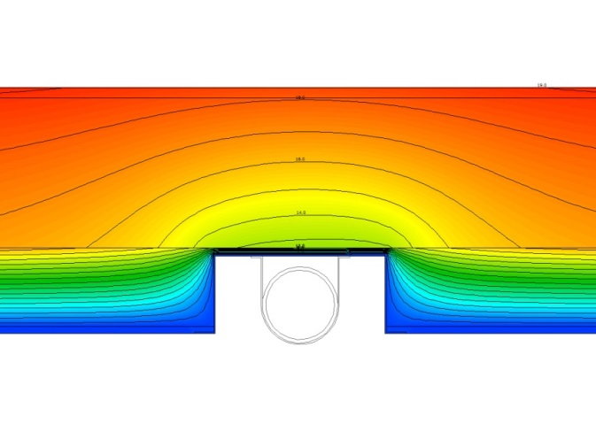

**With Thermo-Pro**

**INTRODUCTION**

**Cold Bridging in EWI**

Enviroform Solutions have developed a number of unique products using Aerogel insulation combined with various materials, to tackle the issue of cold bridging and weathering at key junctions when installing External Wall Insulation.

The Key Junctions in question are:

1. Windows & Door – Reveals, Cills
2. Soil Pipes – Gate Posts
3. Eaves- Gutter- where no overhanging soffit exists
4. Lead Flashing Details – Bay windows – Single storey beside Two Storey
5. Below DPM Level

Thermo-Pro® **Range**

1. **Thermo-Bead**
2. **Thermo-Pro-Soil Pipe**
3. **Thermo-Pro-Eaves/Gutter**
4. **Thermo-Flash**
5. **Thermo-Trac**

Failure to identify and adequately deal with these cold bridging elements can lead to

1. Increased heat loss from a dwelling compared with what was assumed during energy modelling.
2. The risk of condensation or mould growth from lowered internal Surface temperature at or near the Thermal Bridge Junction.

**Without Thermo-Pro**

Without Thermo-Pro®

With Thermo-Pro®

**Thermal Graphics**

20oC

0

By introducing the insulated profile the linear thermal transmittance is reduced by over **70%** and the internal surface temperature is increased by 2.2oC significantly reducing the risk of condensation creating a healthy indoor environment.

**1** Thermo-Bead

**1** Thermo-Bead

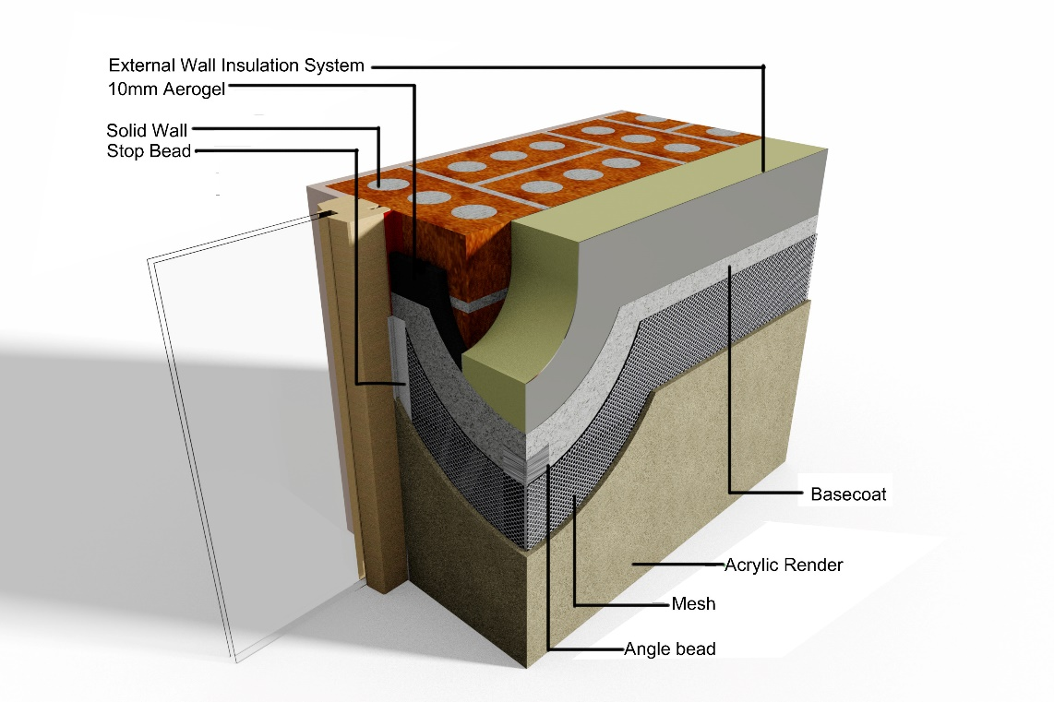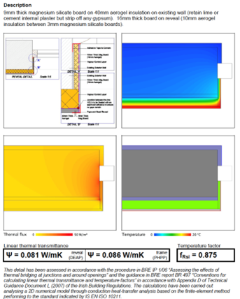

**With Thermo-Pro**

**Without Thermo-Pro**

Thermo-Bead

**KEY ADVANTAGES**

Using Thermo-Bead with 10mm of Aerogel insulation provides the same thermal resistance as 23mm of Graphite EPS saving 13mm of valuable space for window and door openings.

* **Thermo-Bead** 10mm + 7mm Coating = 17mm
* Graphite EPS 23mm + 7mm Coating = 30mm

**DESCRIPTION**

**Thermo-Bead** is a fast, cost effective and ultra-thin solution to deal with the cold bridging at external window reveals.

**Thermo-Bead** comprises of standard beads insulated with 10mm of Aerogel insulation and integrates seamlessly into all existing EWI systems leaving a finished depth of just 17mm.

**Thermo-Bead**

**16mm**

**Graphite EPS – 29mm**

**2** Thermo-Pro® **Soil Pipe**

**2** Thermo-Pro® Soil Pipe

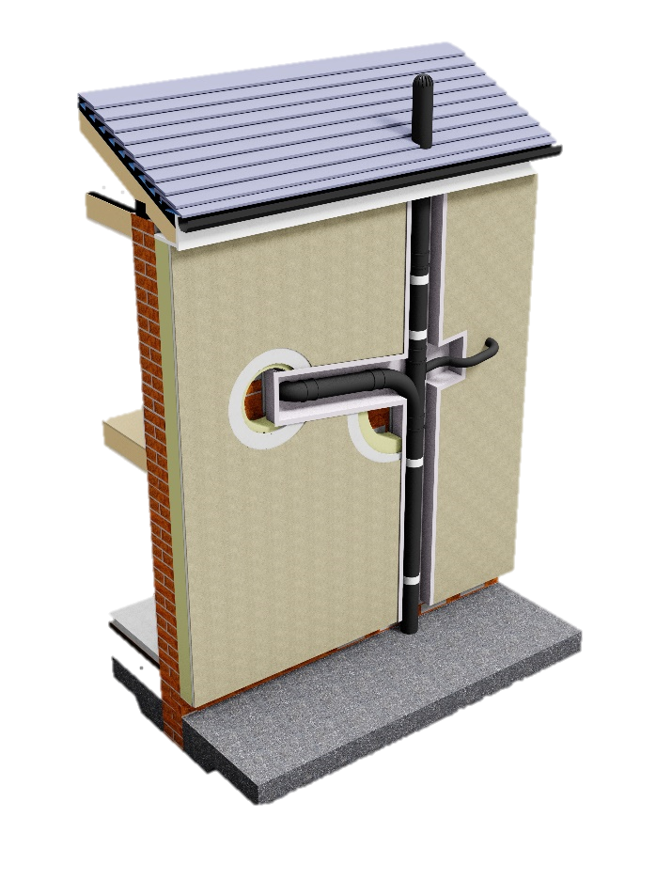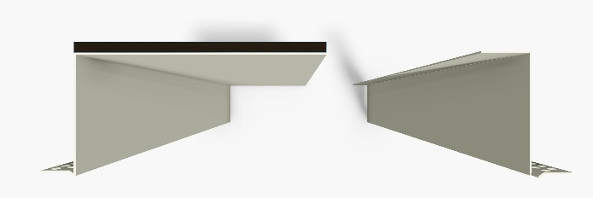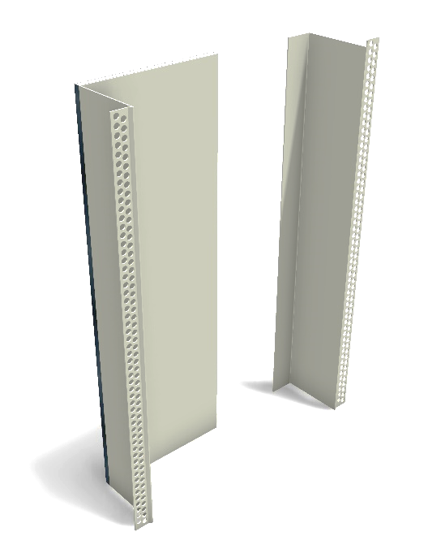

**THERMO-PRO SOIL PIPE**

**DESCRIPTION**

The **Thermo-Pro** system facilitates continuity of the thermal envelope upgrade without the need, or the disruption of removing, realigning and potentially damaging the existing service system

**Thermo-Pro** is made up of 10mm foil faced high performance Aerogel Insulation laminated to custom designed powder coated aluminium profiles.

The Insulated profile simply integrates into existing EWI systems.

**KEY ADVANTAGES**

* Faster Installations.
* Reduce risk of onsite damage.
* Weatherproofed and Pre-finished solution.
* No thermal breaks in EWI.
* Reduced Disruption to assess.
* The Thermo-Pro profile can be fitted ahead of the main insulation works without scaffolding.
* Simplifies the job of the primary EWIS contractor.

**European Patent No. 2703574**

Thermo-Pro®

Soil Pipe

EWI System

Thermo-Pro®

Soil Pipe

Thermo-Pro®

Soil Pipe

Thermo-Pro®

Soil Pipe

10mm Aerogel Insulation wrapped in VCL

Powder coated

Aluminium

The **Thermo-Pro** range of profiles has been developed to provide a weather tight and thermal bridging solution for external wall insulation systems.

**APPLICATION**

* Soil Pipes.
* Gateposts.

**3** Thermo-Pro® **Rainwater- Fascia & gutter box**

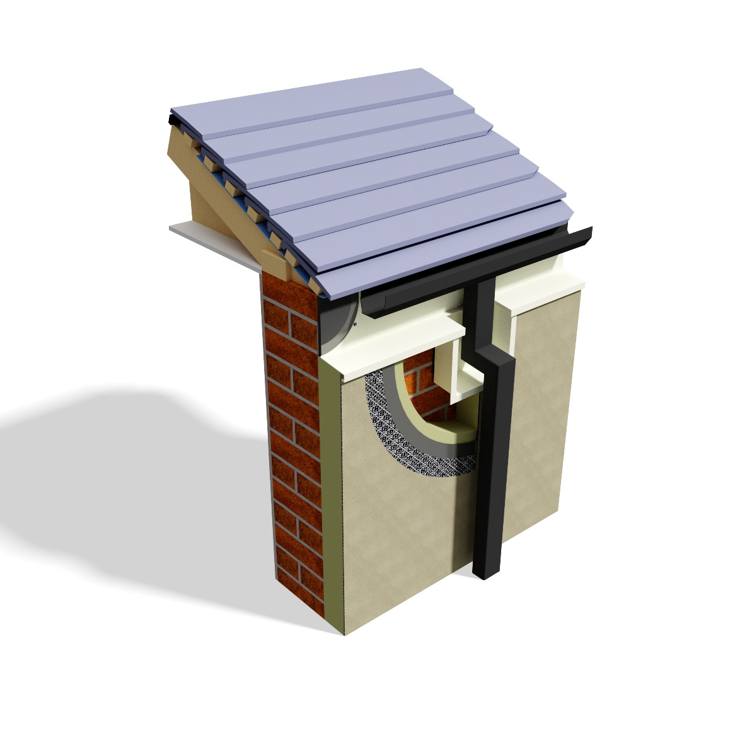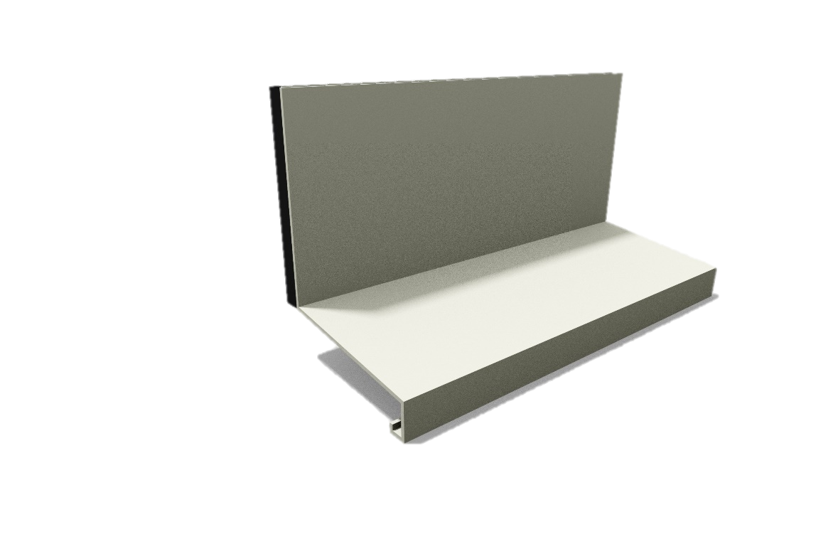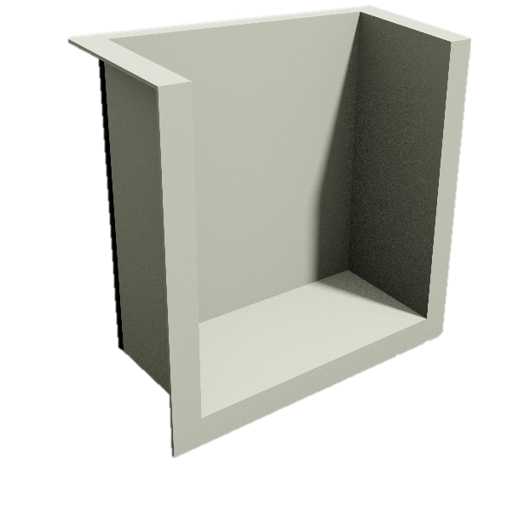

**European Patent No. 2703574**

Foil Wrapped Aerogel

Thermo-Pro®  Facia

Thermo-Pro®  Gutter Box

EWI System

Thermo-Pro® **Gutter**

Thermo-Pro®

**Fascia**

**DESCRIPTION**

The **Thermo-Pro** Fascia profile is used to insulate up to the roof level when there is no soffit on the property.

The existing guttering will have to be removed temporarily to allow insulated flashing to be installed, however if the guttering is in poor condition we would recommend that the guttering is replaced to protect the long-term performance of the insulation upgrade.

The insulated gutter boxes simply allow the thicker insulation to be installed as high up the wall by allowing the slim neck piece of the gutter to cut into the EWI system.

The gutter box can also be used at the bottom to allow the downpipe to drain into the original gully and prevent overspill during heavy rain.

Powder coated

Aluminium

10mm Aerogel Insulation wrapped in VCL

Thermo-Pro®

**Gutter Box**

**4** Thermo-Flash - **Thermally Insulated Flashings**

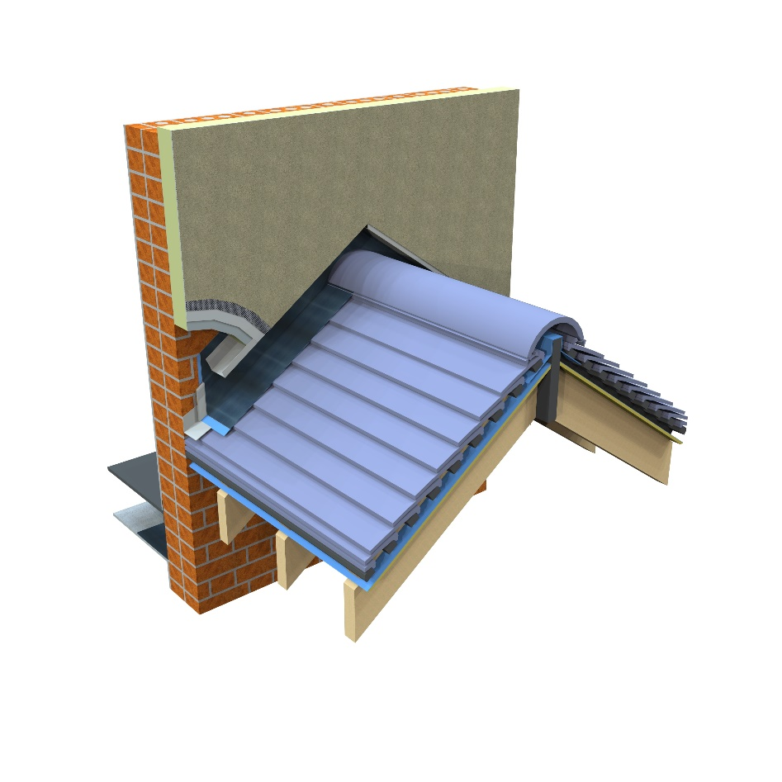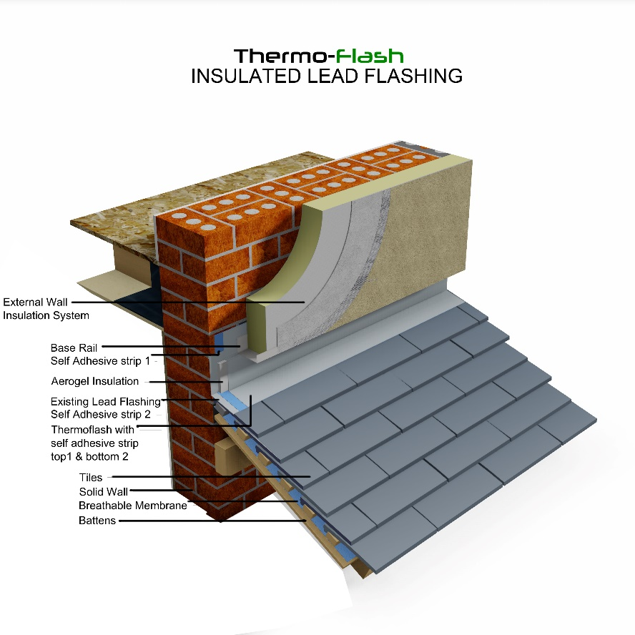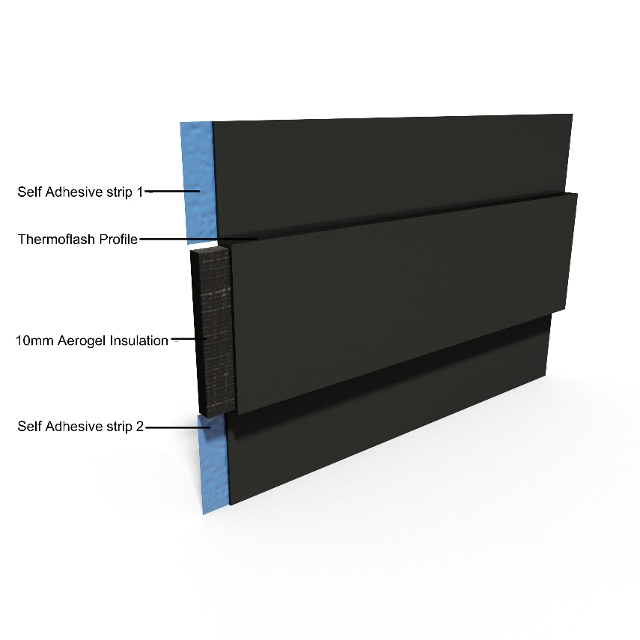

Thermo-Flash

**Thermo-Flash** is a very simple but also very effective solution that has been developed to prevent cold bridging in key areas in existing properties. This solution comprises of 10mm high performance Spaceloft Aerogel insulation wrapped in a VCL with aluminium or Lead flashing.

**Key areas of use**

* Bay Window
* Lead flashing – Connecting wall and Roof Junctions
* Parapet roofs

**Key advantages**

* Reduction of thermal bridging
* Improved weatherproofing
* Aesthetically pleasing
* Easy to install
* Cost effective

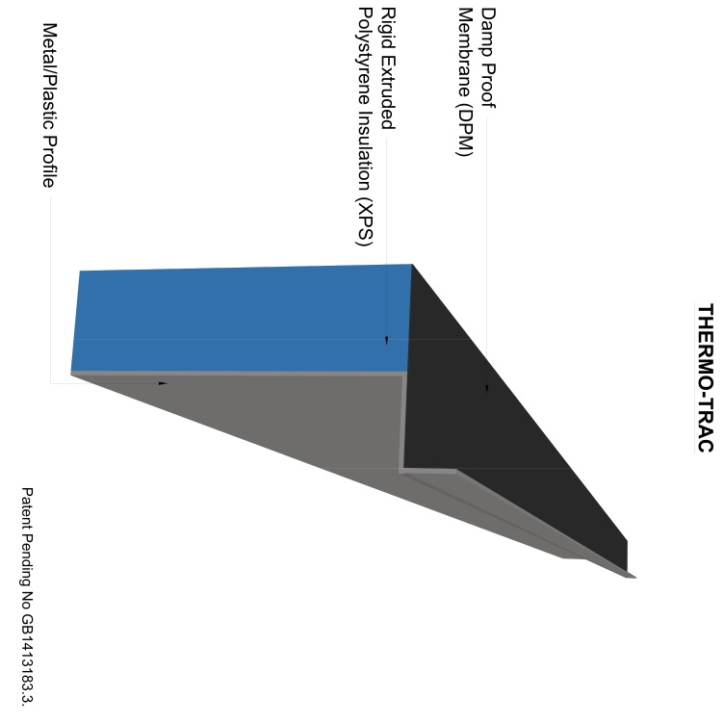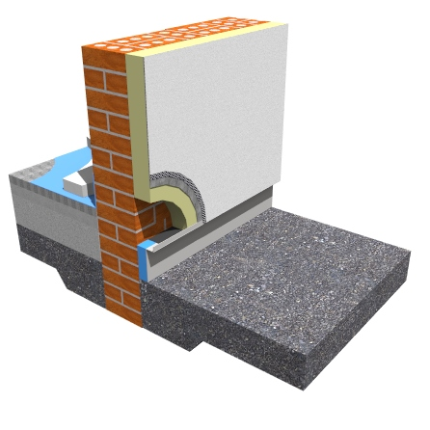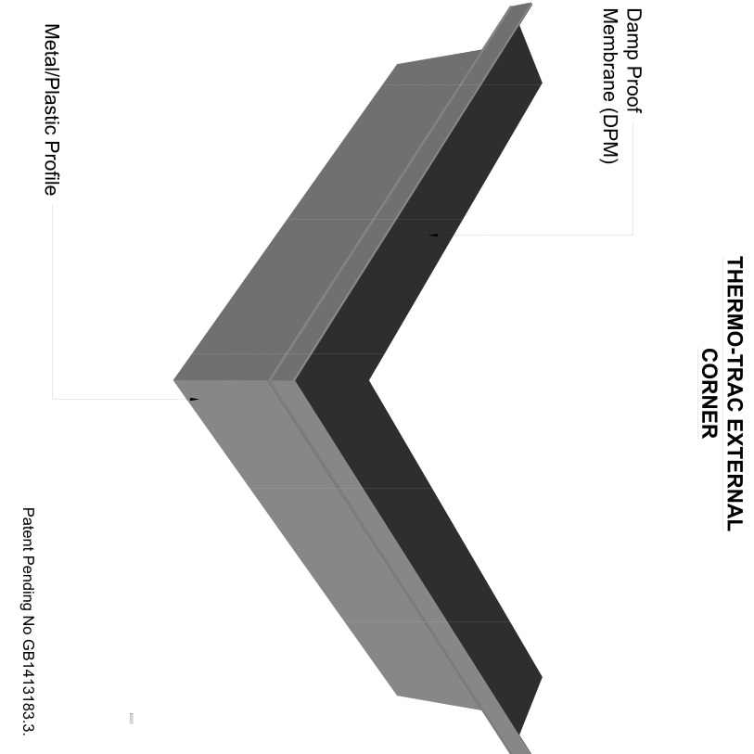

Thermo-Trac

**External Corner**

Thermo-Trac

**5 “”** Thermo-Trac -**Thermally Insulated Base Rail**

**Thermo-Trac** is a prefinished insulated base rail with an integrated damp proof membrane layer used for eliminating cold bridging below the DPM zone. Simply bedded into a specially designed water proof mortar, it can be efficiently installed and levelled from both the vertical and horizontal plain. The product can be easily cut to allow for sloping or rising plinth details leaving a clean aesthetically pleasing finish.

**Key areas of use**

* Below DPM

**Key advantages**

* Elimination of cold bridging.
* Pre finished aluminium.
* Pre manufactured corners.
* Aesthetically pleasing.
* Easy to install.
* Cost effective.

|  |  |  |
| --- | --- | --- |
| **External Cold Bridging Products** | | |
|  | **No.** | **Items** |
| **Thermo-Bead - To insulate window and door reveals** | | |
| C:\Users\User\AppData\Local\Microsoft\Windows\Temporary Internet Files\Content.Outlook\XCJ4FJFR\Thermo-Bead.jpg | **TB5** |  |
|  | **TB5/1** | 5mm x 50mm x 2500mm |
|  | **TB5/2** | 5mm x 75mm x 2500mm |
|  | **TB5/3** | 5mm x 100mm x 2500mm |
|  | **TB5/4** | 5mm x 125mm x 2500mm |
|  | **TB5/5** | 5mm x 150mm x 2500mm |
|  | **TB10** |  |
|  | **TB10/7** | 10mm x 50mm x 2500mm |
|  | **TB10/8** | 10mm x 75mm x 2500mm |
|  | **TB10/9** | 10mm x 100mm x 2500mm |
|  | **TB10/10** | 10mm x 125mm x 2500mm |
|  | **TB10/11** | 10mm x 150mm x 2500mm |
| **Thermo-Flash - Overclading and insulating existing flashing** | | |
|  | **TF1** | 3000mm x 370mm |
|  |
|  |
|  |
|  |
|  |
| **Thermo-Trac - Insulating and finishing below DPM** | | |
|  | **TT1** | 60mm x 150mm x 2500mm |
|  |
|  | (to suit 90mm EPS) |
|  | **TT2** | 80mm x 150mm x 2500mm |
|  |
|  | (to suit 110mm Mineral Wool) |
| **Thermo-Joint - Jointing piece for above** | | |
| C:\Users\User\AppData\Local\Microsoft\Windows\Temporary Internet Files\Content.Outlook\XCJ4FJFR\Thermo-Trac Jointing Piece.jpg | **TJ1** | 130mm x 150mm |
|  |
|  |
|  |
|  |

|  |  |  |
| --- | --- | --- |
| **External Cold Bridging Products** | | |
|  | **No.** | **Items** |
| **Thermo-Trac External Corner - Pre-manufactured corner** | | |
| C:\Users\User\AppData\Local\Microsoft\Windows\Temporary Internet Files\Content.Outlook\XCJ4FJFR\Thermo-Trac External Corner.jpg | **TTEC1** | 60mm x 150mm x 500mm x 500mm |
|  |
|  |
|  | **TTEC2** | 80mm x 150mm x 500mm x 500mm |
|  |
|  |
| **Thermo-Trac Extended External Corner - Pre-manufactured extension corner** | | |
| C:\Users\User\AppData\Local\Microsoft\Windows\Temporary Internet Files\Content.Outlook\XCJ4FJFR\Thermo-Trac External Extended Corner (2).jpg | **TTEC3** | 60mm x 300mm x 500mm x 500mm |
|  |
|  |
|  | **TTEC4** | 80mm x 300mm x 500mm x 500mm |
|  |
|  |
| **Thermo-Trac Corner (Internal) - Pre-manufactured internal corner** | | |
|  | **TTIC1** | 60mm x 150mm x 500mm x 500mm |
|  |
|  |
|  | **TTIC2** | 80mm x 150mm x 500mm x 500mm |
|  |
|  |
| **Thermo-Trac Extended Corner (Internal) - Pre-manufactured internal extention corner** | | |
| C:\Users\User\AppData\Local\Microsoft\Windows\Temporary Internet Files\Content.Outlook\XCJ4FJFR\Thermo-Trac Internal Extended Corner.jpg | **TTIC3** | 60mm x 300mm x 500mm x 500mm |
|  |
|  |
|  | **TTIC4** | 80mm x 300mm x 500mm x 500mm |
|  |
|  |

|  |  |  |
| --- | --- | --- |
| **External Cold Bridging Products** | | |
|  |  |  |
|  | **No.** | **Items** |
| Thermo-Pro®**Fascia - To insulate behind existing guttering** | | |
|  | **TPF1** | 11mm x 100mm x 2500mm PC  (Pre-coated) |
|  |
|  |
|  | **TPF2** | 11mm x 100mm x 2500mm PC  (Powder coated) |
|  |
|  |
|  |  |  |
|  | **No.** | **Items** |
| Thermo-Pro®**® Rainwater Boxes - To compliment the above with Swan neck pieces** | | |
|  | **TPGT** | Top |
|  |
|  |
|  | **TPGB** | Bottom |
|  |
|  |
|  |  |  |
|  | **No.** | **Items** |
| Thermo-Pro® **Soil Pipe (2 Pc) - To insulate behind existing soil pipes which cannot be removed** | | |
|  | **TPSP1** | Z side Profile |
|  |
|  |
|  | **TPSP2** | Z Insulated Profile |
|  |
|  |

Relevant Patent Numbers: GB1413183.3, E 13195976.9, E 2703574

Thermo-Pro® Registered Trademark No. UK00003119586



**TELEPHONE**

+44 (0)28 4177 3314

**EMAIL**

info@enviroformsolutions.com

**TELEPHONE**

+44 (0)28 4177 3314

**EMAIL**

info@enviroformsolutions.com

**ADDRESS**

16 Milltown Industrial Estate

Upper Dromore Road

Warrenpoint

Co Down

BT34 3PN